REPORT ON THE VİSİT OF DR. DAVİD ROSENFELD TO THE TURKİSH PROVİSİONAL SOCİETY OF PSİKE (2 -6 DECEMBER 2015)
The provisional society of Psike at Istanbul has had the extraordinary chance to host David Rosenfeld between the 2nd and the 6th of December 2015. A 5 day long visit, creating a glimpse of opportunity to grasp the richness and flexibility of an analytic stance colored by transcontinental and transcultural experience.
On the 2nd of December the program started with a Conference at the society’s place, at which Dr. Rosenfeld presented a paper named “Psychotic Addiction to Video Games”. The conference was open to psychoanalysts and candidates from the society. Rosenfeld described his exciting but also difficult journey towards gaining entry into Lorenzo’s terrifying world, which was populated by savage video- game characters. At the end of the analytic process the 17-year-old adolescent was able to create a space between symbol and symbolized, between reality and fantasy. It was a detailed account of the clinical experience an analyst would undertake on his road to the most painful corners of a psychotic’s internal world. On the 3rd of December, another meeting was held, chaired by the society’s president Gülgün Alptekin. This time an analyst from the society, Sevil Kural presented her own work with a young patient whose internal world was similarly populated by characters from childhood engaged in ferociously attacking each other. It was a fruitful case study in which analysts, candidates and Dr. Rosenfeld exchanged experience and understanding about clinical work, the importance of working in the analytic process guided by the countertransference experience was underlined and stressed. On these 2 days, Dr. Rosenfeld gave also private supervision to members of the society.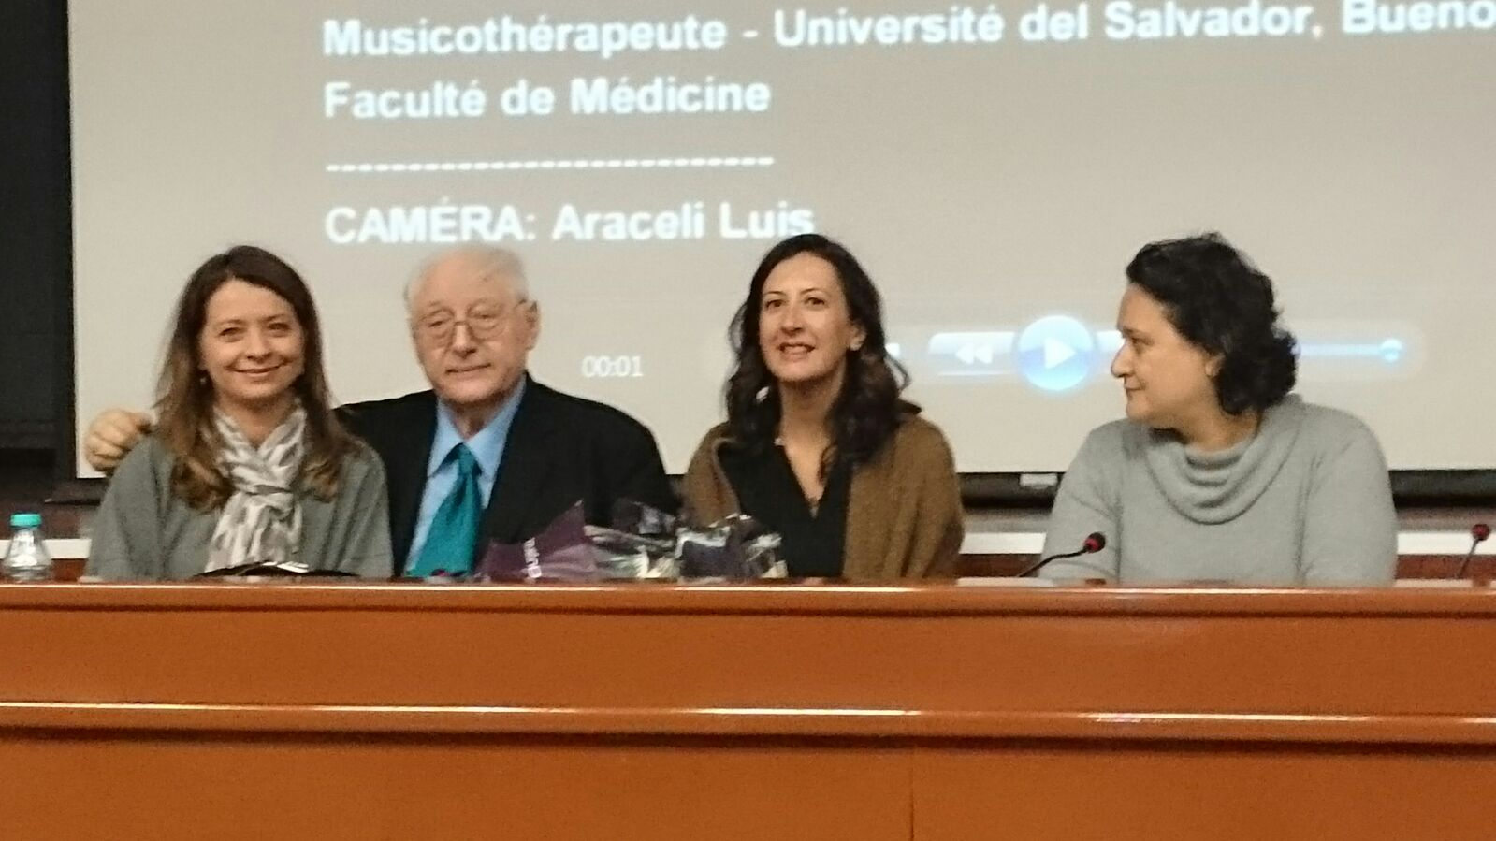
On Friday, the 4th of December, Dr. Rosenfeld gave a 4 hours lecture at Bakırköy Mazhar Osman Mental Health and Neurological Diseases Education and Research Hospital. The conference was attended by nearly 400 psychiatry residents, consultants, psychologists, social workers and nurses, working mostly in the same hospital, but also in some other institutions for mental health. A documentary film was shown, “I’m a real kid now”, depicting step by step the treatment of an autistic boy named Benjamin; then Dr. Rosenfeld shared and commented on his work with Benjamin, the audience had the chance to discuss and share about experience with severely disturbed and psychotic patients. İdeas on psychotic mechanisms were exchanged and ways of working with psychotic patients through transference and countertransference were discussed. In the last part of the conference thoughts about families’ supportive roles in psychotic patients were discussed and that part was opened to the public: family members, relatives, caretakers, even residents of the neighborhood attended.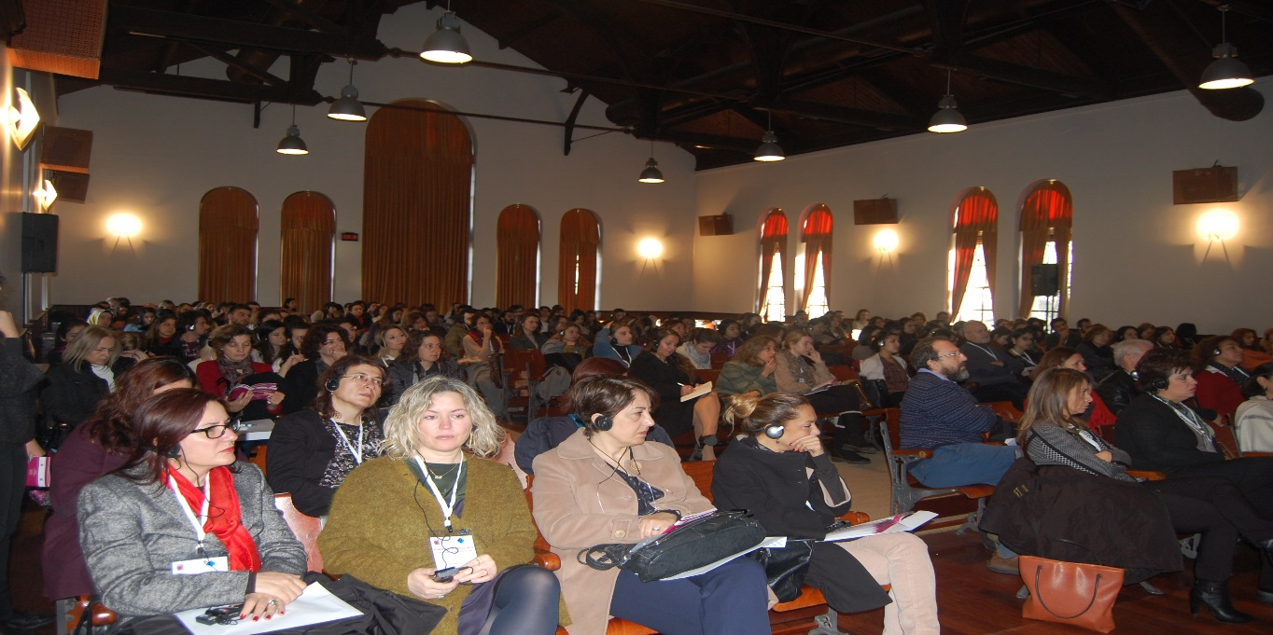
On the 5th of December the annual symposium organized by Psyche started. The theme was “Violence within, violence we live in”. The aim was to explore and discuss the dark but also indispensible part of the human psyche that shapes the everyday experience but at the same time can be the shadow cast on our psyche by the violence of the external world. It was an exciting experience to have such a theme of discussion in the light of the social and political events affecting the world and the country at that time. Dr. Rosenfeld’s lecture was the first one: “September 11th Military Dictatorship and Psychotic Episode”. It was a moving and exciting lecture, where it is difficult to put into words how a speaker and an audience were brought together by the deep emotional involvement the lecture created. Dr. Rosenfeld described his way of working in an analytic frame that reflects who the patient is and what she or he needs in order to make use of an analytic process. The creation and the availability of a reliable holding environment as a further step in the treatment was described and more than that holding environment was created by the work of putting into verbally symbolized form the psychotic experience of the patient. The interpretative work described was mostly guided by the countertransferential experience. Together with that, the intuitive grasp of issues in the analytic relationship offered by Dr. Rosenfeld was impressive. An opportunity was created to understand, to see the concept of autistic encapsulation, playing such a great role in the defences of the psychotic personality. The audience consisted of analysts and candidates from the society, psychologists and psychiatrists, child psychiatrists and psychologists, psychology students, social workers, some analysts from Switzerland and England. Nearly 400 participants had the chance to listen, to discuss and exchange experience and understanding of the role violence can play in human psyche.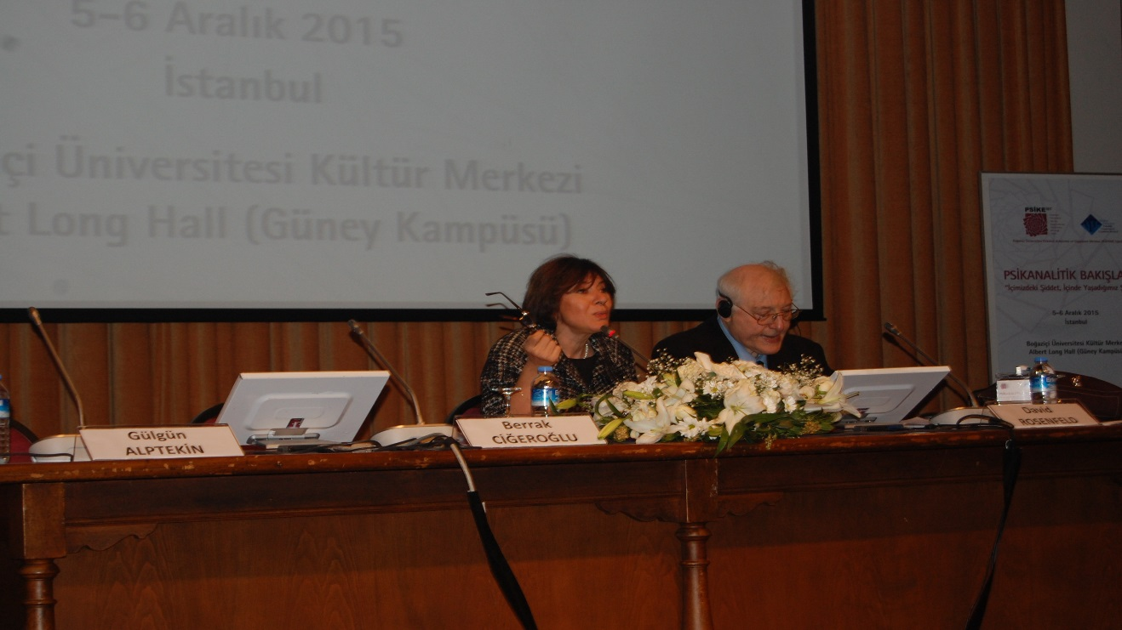
On the second day of the symposium there was a workshop with Dr. Rosenfeld, moderated by Tijen Demirörs, where a candidate from the society- Onur Saltuk Dönmez presented a case. The story of a young woman with intimate relationship problems step by step revealed the role of an omnipotent and violent mother in the past, and the never ending mourning of a father who could, but did not happen to be the savior from the oppressive relationship. The works of Klein, Winnicott, Mahler, D. Anzeu were shortly overviewed in the light of the case and the participants eagerly shared views about the case.
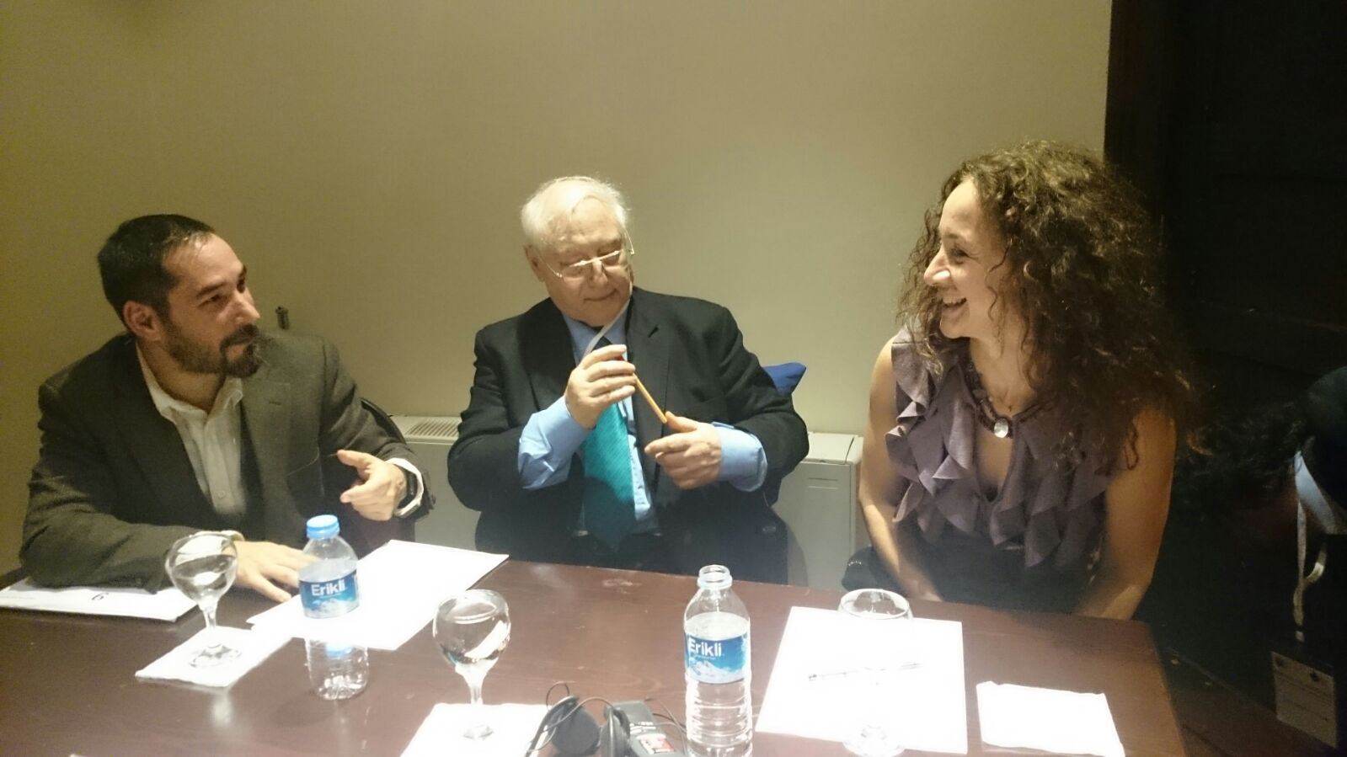
Sharing thoughts, ideas, experiences with Dr. Rosenfeld in the frame of the activities above has been of great importance to us and we remain enriched, enlightened and inspired by what we have exchanged. We believe such an exchange is of great contribution to the development of better understanding in the field and it is an opportunity also to thank to IPA and CAPSA for the support, for having made it possible for us.
Sevil Kural
Representative of the Scientific Committee at Psike İstanbul

